INSTRUCTIONS FOR COMPLETING STATE OF WASHINGTON  MOTOR VEHICLE COLLISION REPORT | 
WHEN TO COMPLETE AND SUBMIT
BEFORE YOU BEGIN, THINGS TO KNOW
Completing online version: (www.wsp.wa.gov, search for “Collision Reporting,” then s•Print this document single-sided, not double-sided, upon completion. | croll down to “Citizen Reports”)
•Retain a copy for your records.  Completing printed version:  • Print using a black ball-point pen—do not use a pencil or felt-tip pen.  •Keep the carbon copy for your records. | SPECIAL NOTE:  Please print this document single-sided, not double-sided.
When information is not applicable or available: Leave that portion of the form blank. Submitting online or printed version: Mail to address above; neither version can be e NOTE: A “unit” is a motor vehicle, pedestrian, pedalcycle, and/or a property owner. Yo always be Unit 1. | -mailed or faxed.  u, as the involved party, will
WHAT WE ARE REQUESTING IN SPECIFIC FIELDS
Report Number | This is an auto-generated number. Leave this field blank.
Date of Collision | Date collision occurred. If the date of the collision is unknown, use the date the damage was discovered (mandatory field).
Day of Collision | Checktheappropriatebox.
Time of Collision | Time collision occurred or time the damage was noticed (check a.m. or p.m. box).
Investigated By | Check the appropriate box for the law enforcement agency that investigated the collision OR indicate “No Investigation” if law enforcement did not investigate.
Collision Involved | Check the appropriate box if anyofthefollowingapply:VehicleFire/Hit&Run/StolenVehicle. Indicate Total#ofUnits(vehicles/partiesinvolved),Total#Injuries,Total#Deaths.
Place Where Collision Occurred | COUNTY: The county where the collision occurred. If unknown, use the county where the damage was discovered (mandatory field).  CITY OR TOWN: The city or town where the collision occurred.
Road Surface | Check the appropriate box(es) for the road surface conditions at the time of the collision.
Weather | Check the appropriate box(es) for the weather conditions at the time of the collision.
Light Conditions | Check the appropriate box(es) for the light conditions at the time of the collision.
Location of Where Collision Occurred | Identify the name of the street/highway you were on or the address or name of the parking lot. Example:  Interstate – I-5, I-82, I-205, or I-705 City Street – a street or road within the city Other–parks,campus,forestserviceroad, military base State Route – SR-20, Highway 99, SR-101 County Road – a street or road outside the city PrivateWay–privateroad,shoppingmall, parking lot, driveway
Distance From | Indicate the distance from the street or location indicated under “Location of Where Collision Occurred” and check the appropriate boxes for feet/miles and direction.  Example: 3.0 miles north or 200 feet east
Nearest Street or Land Mark | Indicate the nearest street or land mark to the collision location.  Example: Exit120,CapitalMall,LindersonWaySW,3.0milesnorthof 22nd Avenue, and/or 200 feet east of Capital Mall
Was Driver Distracted | Check the appropriate box and indicate what the distraction was (if more room is needed, attach additional blank pages or use additional Was Driver Distracted pages).
Describe Below What Happened | Refer to the vehicles as units and explain to the best of your knowledge what occurred (if more room is needed, attach additional blank pages or use additional Describe Below pages).
At Moment of Collision | Identify each unit and check the appropriate box to indicateiftheunitwasparked/stopped/moving.
Diagram | Draw a picture of roadway/intersection/parking lot, etc. Show your unit (vehicle)/others involved.
Witness Name | List names, addresses, and phone numbers of any witnesses (if more room is needed, attach additional blank pages or use additional Witness pages).
Signature/Date of Report | The person completing the form must sign and date the form and provide his or her address. The signature is a legal requirement (mandatory field).
3000-345-161 (R 1/15)

WHAT WE ARE REQUESTING IN SPECIFIC FIELDS (continued) | 

Unit | The person completing the report should be Unit 1. Unit 2 is the other party involved. If more parties are involved, attach additional blank pages or use additional Units Involved pages. A unit may be a motor vehicle (motorcycle, etc.), pedalcycle (bicycle, tricycle, unicycle), pedestrian (wheelchairs, skateboards, and roller skates), or property owner (fence, yard, trees, ditch, etc.) that had damage. If you are a property owner, enter in the name, address, and estimated cost for repair. Check the appropriate box to indicateifyou are a motor vehicle, pedalcycle,  pedestrian, or property owner.
Was Helmet Used | Check the appropriate box to indicate if a helmet was used if you were a motorcyclist, pedalcyclist, skater, or skateboarder.
Name | Provide your full last name, full first name, and middle initial.
Sex | Check the appropriate box.
Address | Provide your full address and/or a mailing address (check the box if this is a new address), city, state, and ZIP code.
Driver’s License # | Provide your driver’s license number.
State | Indicate the state that issued your driver’s license.
Date of Birth | Provide the month, date, and year you were born.
License Plate/State | Provideyourlicenseplatenumberandthestatewherethevehicleisregistered.
VIN | ProvidetheVehicleIdentificationNumber.Itcanbe10to17characterslong(foundonthe vehicle registration or on your insurance card).
Trailer Plate # | If you were pulling a flatbed, camping trailer, etc., provide the license plate number and state.
Estimated Cost to Repair Vehicle or Object Struck | Estimate the cost to fix your vehicle or the object struck.
Vehicle Year | Provide the year of your vehicle.
Make | Provide the make (i.e., Ford, Chevrolet, Dodge, etc.).
Model | Provide the model (i.e., Taurus, Lumina, Charger, etc.).
Body Style | Providethebodystyle (i.e.,2door,4door,hatchback, etc.).
Registered Owner | Provide the full name, address, state, and ZIP code of the registered owner.
Was Auto Liability  Insurance in Effect at Time of the Collision | Check the appropriatebox.
Insurance Company and Policy Number | Provide the name of your insurance company and policy number.
Nature of Injuries | Indicate the type of injuries, if any (head pain, chest pain, legs hurt, etc.).
Mark if This Unit Was a Commercial Vehicle | Indicate if this was a commercial vehicle. Types of commercial vehicles may include cement truck, semi with attached trailer, school bus (vehicle with a gross vehicle weight rating [GVWR] of more than 26,000 pounds).
Shade In Damaged Area of Vehicle | Shade in the area where damage occurred on the vehicle.
Passengers | Identify passengers by the unit number they belong to (i.e., Unit 1, Unit 2, etc.). If there were more than two passengers, use an additional Units Involved page for other passengers.  Complete the passenger fields as follows:
 | Name | Provide the full last name, full first name, and middle initial.
 | In Unit # | Indicate which unit they were in (i.e., Unit 1, Unit 2, etc.).
 | Sex | Check the appropriate box.
 | Address | Provide full address and/or mailing address including city, state, and ZIP code.
 | Date of Birth | Provide the month, day, and year they were born.
 | Nature of Injuries | Indicate the type of injuries incurred.
 | If Motorcyclist or Pedalcyclist Was Helmet Used | Check the appropriate box.
3000-345-161 (R 1/15)

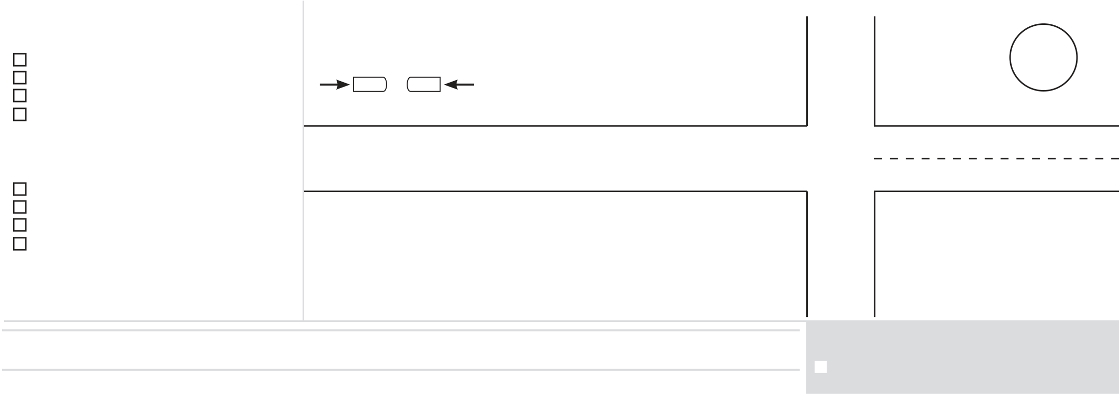

 | STATE OF WASHINGTON VEHICLE  COLLISION  REPORT | SPECIAL NOTE:  Please print this document single-sided, not double-sided. | REPORT NO.

DATE OF COLLISION  M M D D Y Y Y Y | DAY OF COLLISION  SUN MON TUE WED THU FRI SAT   | TIME OF COLLISION HOURMINUTES    AM   PM | INVESTIGATED BY:  STATE PATROL  CITY POLICE  SHERIFF  OTHER POLICE  NO INVESTIGATION | COLLISION INVOLVED STOLEN VEHICLE  VEHICLE FIRE HIT & RUN  TOTAL # UNITS TOTAL # INJURIES TOTAL # DEATHS  UNITS = MOTOR VEHICLE, PEDESTRIANS, PEDALCYCLE AND/OR PROPERTY OWNER
PLACE WHERE COLLISION OCCURRED
COUNTY |  |  |  |  |  |  |  |  |  |  |  |  |  |  |  |  | ROAD SURFACE   DRY  SAND/MUD  WET OIL   SNOW  STANDING WATER   ICE   OTHER | WEATHER   CLEAR/PTLY CLOUDY  FOG  OVERCAST SLEET   RAINING  SEVERE CROSSWIND   SNOWING  OTHER | LIGHT CONDITIONS  DAYLIGHT DARK-STREET LIGHTS ON  DAWN  DARK-STREET LIGHTS OFF  DUSK  DARK-NO  STREET LIGHTS  OTHER
CITY OR TOWN
LOCATION OF WHERE COLLISION OCCURRED:
NAME OF STREET/HIGHWAY YOU WERE ON OR ADDRESS/NAME OF PARKIN
__________________________________________________________________
DISTANCE FROM ______ . ______ in FEET | MILES | N |  | E |  | S
NEAREST STREET OR LAND MARK (BRIDGE, RR CROSSING, OTHER LAND MARK): __________________________________________________________________
WAS DRIVER DISTRACTED
UNIT #____ |  | YES | NO
UNIT #____ |  | YES | NO
DISTRACTIONS INCLUDE: OPERATING A
TELECOMMUNICATION DEVICE, ELECTRONIC
DEVICES, PDA, LAPTOP COMPUTER, NAVIGATION
DEVICES, ADJUSTING AN AUDIO OR ENTERTAINMENT
SYSTEM, SMOKING, INSIDE DISTRACTIONS, OUTSIDE
DISTRACTIONS, EATING OR DRINKING, ANIMALS,
PASSENGERS, ETC.
DISTRACTED BY: ___________________________________
DESCRIBE BELOW WHAT HAPPENED(REFER TO UNITS BY NUMBER)

AT MOMENT OF COLLISION: UNIT #____ | INDICATE ON THIS DIAGRAM  WHAT HAPPENED |  | DIAGRAM | SHOW NORTH BY ARROW IN CIRCLE
 | 1. TRACE THE OUTLINE THAT REFLECTS YOUR COLLISION SCENE, WRITING IN STREET OR HIGHWAY NAMES.
PARKED UNOCCUPIED | 2. NUMBER EACH UNIT AND SHOW DIRECTION OF TRAVEL BY ARROW |  |  | STREET OR HIGHWAY _______________________
PARKED OCCUPIED
 | 1 | 2
STOPPED
MOVING
AT MOMENT OF COLLISION: UNIT #____
PARKED UNOCCUPIED
PARKED OCCUPIED  STOPPED  MOVING |  |  |  |  | STREET OR | HIGHWAY _____________
WITNESS NAME |  | ADDRESS | PHONE NUMBER |  | (OFFICIAL USE ONLY)  UNIT #____ WAS ON-DUTY LAW ENFORCEMENT OR FIREFIGHTER  (RCW 41.26.030)
1
WITNESS NAME |  | ADDRESS | PHONE NUMBER
2 |  |  |  |  | DATE OF REPORT MO. DAY |  |  | YEAR
SIGNATURE OF PERSON COMPLETING REPORT |  |  | ADDRESS
 |  |  |  |  | M M |  | D D | Y Y Y Y
X
MAIL TO: WASHINGTON STATE PATROL, RECORDS SECTION, PO BOX 42628, OLYMPIA, WA 98504-2628
 |  |  |  |  | PAGE |  | 1 | OF | 2
 | 3000-345-161 (R 1/15) | RESET |  | (Clears all Fields in the Form)

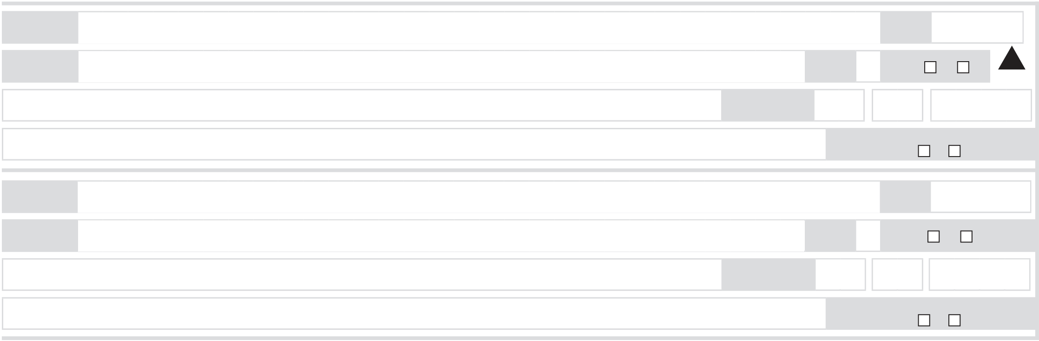


UNITS INVOLVED | REPORT NO.
DRIVER’S LICENSE #

LICENSE
PLATE #

TRAILER PLATE #

VEH YEAR | MAKE (CHEV, FORD) | MODEL (CAMARO, TAURUS)

REGISTERED OWNER (LAST - FIRST - MIDDLE INITIAL)

WAS AUTO LIABILITY INSURANCE IN EFFECT AT TIME OF THE COLLISION? | YES NO | INSURANCE COMPANY AND POLICY NUMBER

(MARK ONLY ONE)  S  STATE  STATE  BODY STYL  OWNER’S ADDRES |  |  | MOTOR  VEHICLE  N  MATED COST T  BJECT STRUC  DR)  REET, CITY, STAT | O RE  K  E & ZI | PEDAL-  CYCLE  ST  D.O  MM-DD  PAIR VEHICLE  P CODE) | .B.  -YYY | PEDESTRIAN  ZIP  Y M  $ | M | PROPERTY  OWNER  MIDDLE  INITIAL  D D | WAS HELMET USED B | MOTORCYCLIST, PEDALCYCLIST,
 |  |  |  |  |  |  |  |  |  | SKATER, SKATEBOARD | ER?
 | YES |  | NO
NATURE OF INJURIES
 |  |  |  |  |  |  |  |  |  | SEX M F
 | TA | TE  VIN |  |  |  |  |  |  |  | Y Y Y Y | MARK IF THIS UNIT WAS  A COMMERCIAL VEHICLE
 | ES O  E  S ( | TI  R O  (2  ST |  |  |  |  |  |  |  | .00 | VEHICLE  SHADE IN DAMAGED AREA  1 2 3 4 5  8 9 TOP  10 BOTTOM  7 6  
UNIT #______
LAST NAME

FIRST NAME

ADDRESS
NEW

CITY

DRIVER’S LICENSE #

LICENSE
PLATE #

TRAILER PLATE #

VEH YEAR | MAKE (CHEV, FORD) | MODEL (CAMARO, TAURUS)

REGISTERED OWNER (LAST - FIRST - MIDDLE INITIAL)

WAS AUTO LIABILITY INSURANCE IN EFFECT AT TIME OF THE COLLISION? | YES NO | INSURANCE COMPANY AND POLICY NUMBER

(MARK ONLY ONE)  S  STATE  STATE  BODY STYL  OWNER’S ADDRES |  |  | MOTOR  VEHICLE  N  MATED COST T  BJECT STRUC  DR)  REET, CITY, STAT | O RE  K  E & ZI | PEDAL-  CYCLE  ST  D.O  MM-DD  PAIR VEHICLE  P CODE) | .B.  -YYY | PEDESTRIAN  ZIP  Y M  $ | M | PROPERTY  OWNER  MIDDLE  INITIAL  D D | WAS HELMET USED B | MOTORCYCLIST, PEDALCYCLIST,
 |  |  |  |  |  |  |  |  |  | SKATER, SKATEBOAR | ER?
 | YES | NO

NATURE OF INJURIES
 |  |  |  |  |  |  |  |  |  | SEX M F
 | STA | TE  VIN |  |  |  |  |  |  |  | Y Y Y Y | MARK IF THIS UNIT WAS  A COMMERCIAL VEHICLE
 | ES O  E  S ( | TI  R O  (2  ST |  |  |  |  |  |  |  | .00 | VEHICLE  SHADE IN DAMAGED AREA  1 2 3 4 5  8 9 TOP  10 BOTTOM  7 6
UNIT #______
LAST NAME

FIRST NAME

ADDRESS
NEW

CITY

PASSENGERS
LAST NAME |  |  |  | D.O.B. | IN UNIT
FIRST NAME |  |  |  |  | MIDDLE  INITIAL |  | SEX |  | M | F
ADDRESS
 |  |  |  |  | M | M | D | D | Y | Y |  | Y | Y
 |  |  |  | MM-DD-YYYY
NATURE OF INJURIES |  |  |  | D.O.B. | IF MOTORCYCLIST OR PEDALCYCLIST WAS
 |  |  |  |  | HELMET USED? |  |  |  | Y | N
LAST NAME
 |  |  |  |  | IN UNIT
FIRST NAME |  |  |  |  | MIDDLE  INITIAL |  | SEX |  | M |  | F
ADDRESS
 |  |  |  |  | M M |  | D | D | Y | Y |  | Y | Y
NATURE OF INJURIES |  |  |  | MM-DD-YYYY
 |  |  |  |  | IF MOTORCYCLIST OR PEDALCYCLIST WAS
 |  |  |  |  | HELMET USED? |  |  |  | Y | N
 | 3000-345-161 (R 1/15) | RESET | (Clears all Fields in the Form) |  | PAGE |  | 2 |  | OF | 2

